**Management Principles for Engineers**

***Lecture Notes***



***Compiled By:***

**Career Development Centre**

**SRM IST**

**Table of Contents**

UNIT 3

3.1 Organisational control

3.2 Motivation

3.3 Leadership

3.4 Organising

3.5 Essentials of organisational design

# UNIT 3

Organisational control - Types of controls – Motivation theories of motivation - Leading Traits of an ethical leader - The nature of leadership - Leadership traits and behaviours - Issues in leadership development - Organising - Organising as a management function - Traditional organisation structures – Essentials of organizational design - Contingencies in organisational design.

## 3.1 Organisational control

Controlling is the process of measuring performance and taking action to ensure the planned outcomes are achieved. Control is aimed at ensuring that plans are fulfilled and that performance targets are met. Control can be important not only for guaranteeing that the performance level is met but also for ensuring that performance is consistent. Carefully controlling the performance levels of an organisation requires accurate and timely flows of information on the key operational variables and outcomes. There is a need for control mechanisms that can quickly detect and correct unlawful and corrupt behaviour at all levels within an organisation.

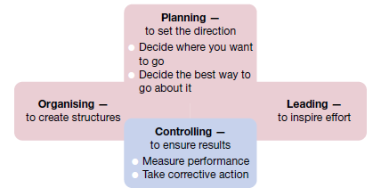

**Fig 3.1: The role of the controlling function in the management process**

**3.1.1 Steps in the control process**

The management control process involves four steps.

1. Establish objectives and standards.

2. Measure actual performance.

3. Compare results with objectives and standards.

4. Take corrective action as needed.

**Step 1: Establish objectives and standards**

The control process starts with planning, when performance objectives and standards for measuring them are set. Performance objectives, furthermore, should represent key results to be achieved. The focus in planning should be on describing ‘critical’ or ‘essential’ results that will make a substantial difference in the success of the organisation. The standards are important, too, and they must also be considered right from the beginning. As key results are identified, the standards or specific measures that will be taken to indicate success or failure in their accomplishment must also be specified.

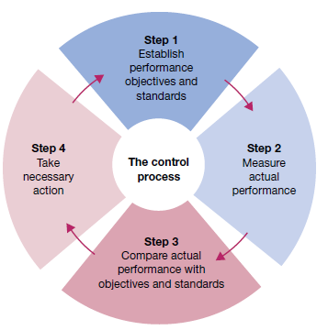

**Fig 3.1.2 Four steps in management control**

Two types of standards are common to the organisational control process. Output standards measure performance results in terms of outcomes like quantity, quality, cost or time taken to accomplish work. Examples of output standards include percentage error rate, dollar deviation from budgeted expenditures, and the number of units produced or customers served in a time period. Input standards, on the other hand, measure effort in terms of the amount of work expended in task performance. They are used in situations where outputs are difficult or expensive to measure. Examples of input standards include conformance to rules and procedures, efficiency in the use of resources, and work attendance or punctuality.

**Step 2: Measure actual performance**

The goal is to accurately measure the performance results (output standards) and/or the performance efforts (input standards). In both cases, the measurement must be accurate enough to spot significant differences between what is really taking place and what was originally planned. A common management failure in this regard is an unwillingness or inability to measure the performance of people at work. Yet without measurement, effective control is not possible. Increasingly, managers are required to assess organisational performance. It can be achieved through analysing statistical/quantitative data collected by employees, supervisors or managers, or by an external organisation, and typically presented in the form of spreadsheets. Alternatively, managers can use qualitative techniques such as observing employees at work. This is often referred to as ‘management by wandering around’ (MBWA).

There are many activities for which it is difficult to develop accurate standards, and there are many activities that are hard to measure. It may be quite simple, for example, to establish labor-hour standards for the production of a mass-produced item and it may be equally simple to measure performance against these standards, but in the less technical kinds of work. For example, controlling the work of the industrial relations manager is not easy because definite standards cannot be easily developed. The superior of this type of managers often rely on vague standards, such as the attitude of labor unions, the enthusiasm, and loyalty of subordinates, the index of labor turnover and/or industrial disputes etc. In such cases, the superior’s measurements are often equally vague.

**Step 3: Compare results with objectives and standards**

The third step in the control process is to compare measured performance with objectives and standards to establish the need for action. This step can be expressed as the following control equation:

Need for action = Desired performance − Actual performance

There are different ways of comparing desired and actual performance. A historical comparison uses past performance as a benchmark for evaluating current performance. A relative comparison uses the performance achievements of other people, work units or organisations as the evaluation standard. An engineering comparison uses engineered standards that are set scientifically through such methods as time and motion studies. For instance, the delivery routines of drivers for a courier company are carefully measured in terms of the expected time taken to make a delivery on various routes.

**Step 4: Take corrective action**

The control equation indicates that the greater the measured difference between desired and actual performance, the greater the need for action. The final step in the control process, accordingly, is taking any action necessary to correct or improve things. This allows for a judicious use of management by exception — the practice of giving priority attention to situations that show the greatest need for action. This approach can save valuable time, energy and other resources, while allowing all efforts to be concentrated on the areas of greatest need.

Two types of exceptions may be encountered. The first is a problem situation in which actual performance is below the standard. The reasons for this performance deficiency must be understood. Corrective action is required to restore performance to the desired level. The second exception is an opportunity situation in which actual performance is above the standard. The reasons for this extraordinary performance must also be understood. Action should then be taken to continue this higher level of accomplishment in the future. The original plan, objectives and standards can also be reviewed to determine whether they should be updated.

For example, the branch manager of a bank might discover that more counter clerks are needed to meet the five-minute customer-waiting standard set earlier. Control can also reveal inappropriate standards and in that case, the corrective action could involve a change in the original standards rather than a change in performance.

**3.1.2 Types of controls**

**3.1.2.1 Process Control**

There are three major types of managerial controls — *feedforward, concurrent and feedback controls*. Each is relevant to a different phase of the organisation’s input–throughput– output cycle of activities. Each offers significant opportunities for actions to be taken that advance organisational productivity and high performance, each offers the opportunity for performance oriented organisational and personal learning through systematic assessment of actions and results.

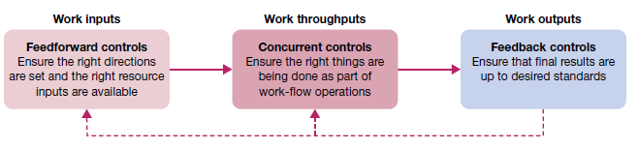

**Fig 3.1.3 Feedforward, concurrent and feedback controls in the management process**

**Feedforward controls**

Feedforward controls, also called preliminary controls, are accomplished before a work activity begins. They ensure that objectives are clear, that proper directions are established, and that the right resources are available to accomplish them, feedforward controls are preventive in nature. They are designed to eliminate the potential for problems later on in the process by asking an important but often neglected question: what needs to be done before we begin? This is a forward thinking and active approach to control rather than a reactive and defensive one. The quality of resources is a key concern of feedforward controls.

**Concurrent controls**

Concurrent controls focus on what happens during the work process. Sometimes called steering controls, they monitor ongoing operations and activities to make sure things are being done according to plan. Ideally, concurrent controls allow corrective actions to be taken before a task is completed. The key question is: What can we do to improve things before we finish? Here, the focus is on quality of activities during the work process. This approach to control can reduce waste in the form of unacceptable finished products or services.

**Feedback controls** Feedback controls, also called post action controls, take place after work is completed. They focus on the quality of end results rather than on inputs and activities. They ask the question: Now that we are finished, how well did we do?

**3.1.2.1 Organisational Control systems**

**1. BUDGETARY CONTROL**

The establishment of budgets, relating the responsibilities of executives to the requirements of a policy

**Revenue and Expense Budgets**

* Budgets spell out plans for revenues and operating expenses in rupee terms.

**Time, Space, Material, and Product Budgets**

* Many budgets are better expressed in quantities rather than in monetary(money) terms.

**Capital Expenditure Budgets**

* capital expenditures for plant, machinery, equipment, inventories, and other items.

**Cash Budgets**

* cash budget is simply a forecast of cash receipts

**Variable Budget**

* analysis of expense items to determine how individual costs should vary with volume of output

**Zero Based Budget**

* By starting the budget of each package from base zero, budgeters calculate costs

**2. NON-BUDGETARY CONTROL TECHNIQUES**

* Many traditional control devices not connected with budgets, although some may be related to, and used with, budgetary controls.

**Statistical data:**

* Analysing the numerical data

**Break- even point analysis**

* chart depicts the relationship of sales and expenses

**3. INFORMATION AND FINANCIAL CONTROLS**

*Liquidity* — ability to generate cash to pay bills;

*Leverage* — ability to earn more in returns than the cost of debt;

*Asset management* — ability to use resources efficiently and operate at minimum cost; *Profitability* — ability to earn revenues greater than costs.

**4. COST CONTROL**

* Cost control is the measure taken by management to assure that the cost objectives set down in the planning stage are attained

**5. OPERATIONS CONTROL**

* **Purchase Control**
* **Inventory Control**
* **Quality Control**

Quality control refers to the technical process that gathers, examines, analyze & report the progress of the project & conformance with the performance requirements

**6. HR FUNCTIONS CONTROL**

* **Remuneration and benefits**
* **Employee discipline systems**

**7. PROJECT MANAGEMENT AND CONTROL**

**Gantt charts**

A Gantt chart, such, graphically displays the scheduling of tasks required to complete a project

**CPM/PERT techniques**

PERT – Project Evaluation and Review Technique

CPM- Critical Path Method

**Levels of Control**

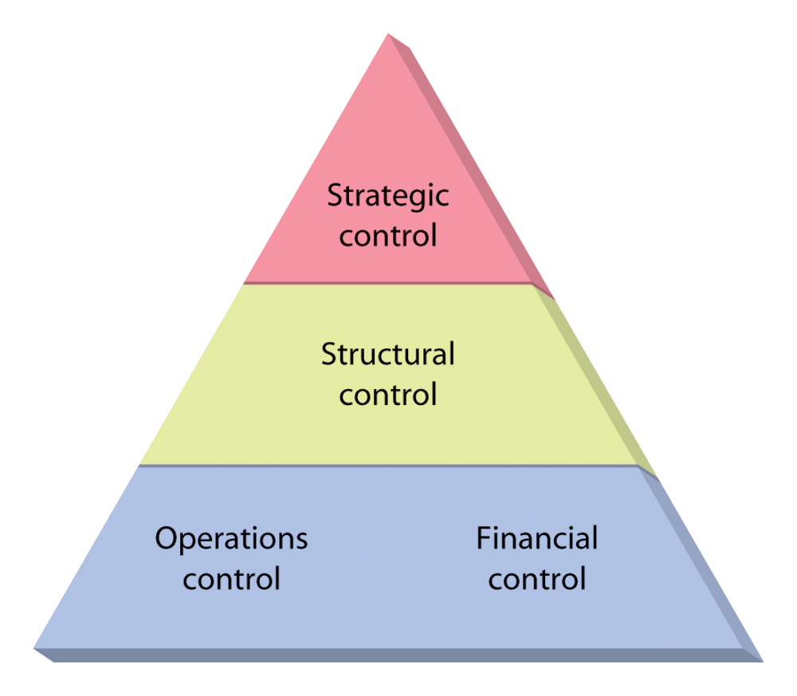

* Operational control:
  + Focuses on the processes used to transform resources into products or services.
* Financial control:
  + Concerned with financial resources.
* Structural control:
  + How the elements of structure are serving the intended purposes.
* Strategic control:
  + How effective are the functional strategies helping the organization meet its goals.

**The difference between Planning and Controlling.**

|  |  |  |
| --- | --- | --- |
| **Basis** | **Planning** | **Controlling** |
| Meaning | It is the first step on deciding what to do, how, where and when a specific work has to be done | Controlling is the main goal and responsibilities of all management in any enterprises. |
| Function | Planning is about looking ahead | Controlling is looking back |
| Process | It is the first process in building a business | It is the last structure any business |
| Features | Planning, arranging, employee, direction | Controls all the planning features |

## 

## 3.1.3 Characteristics of Control:

## 1. Managerial Function:

## Control is one of the managerial functions. It is not only the function of chief executive but is the duty of every manager. A manager is responsible for whatever work is assigned to him. He will control the performance of his subordinates for ensuring the accomplishment of goals. Control is mainly the function of line organization but manager may ask for data from staff personnel.

## 2. Continuous Activity:

## Control is regularly exercised. It is not an activity in isolation. The manager will have to see that his subordinates perform according to plans at all the time. Once the control is withdrawn it will adversely affect the work. So control will have to be exercised continuously.

## 3. Control is Related to Planning:

## Planning is the first function of management while control is the last. Control cannot be exercised without planning. First the objectives are set and then efforts are made to see whether these are accomplished or not. Whenever there is a laxity in performance or things are not happening as per the plans then corrective measures are taken immediately. So planning provides a base for controlling.

## 4. Essence of Control is Action:

## Whenever performance is not as per the standards the immediate action is needed to correct the things. The purpose of control will be defeated if corrective action is not taken immediately. If the sales are less than the standard set for marketing department then steps will be taken to ensure that performance is not low in future. If no such steps are taken then there will be a lack of control. In practice, immediate action is the essence of control.

## 3.1.4 Importance of Controlling

### 1. Accomplishing Organizational Goals

The controlling function is an accomplishment of measures that further makes progress towards the organizational goals & brings to light the deviations, & indicates corrective action. Therefore it helps in guiding the organizational goals which can be achieved by performing a controlling function.

### 2. Judging Accuracy of Standards

A good control system enables management to verify whether the standards set are accurate & objective. The efficient control system also helps in keeping careful and progress check on the changes which help in taking the major place in the organization & in the environment and also helps to review & revise the standards in light of such changes.

### 3. Making Efficient use of Resources

Another important function of controlling is that in this, each activity is performed in such manner so an in accordance with predetermined standards & norms so as to ensure that the resources are used in the most effective & efficient manner for the further availability of resources.

### 4. Improving Employee Motivation

Another important function is that controlling help in accommodating a good control system which ensures that each employee knows well in advance what they expect & what are the standards of performance on the basis of which they will be appraised. Therefore it helps in motivating and increasing their potential so to make them & helps them to give better performance.

### 5. Ensuring Order & Discipline

Controlling creates an atmosphere of order & discipline in the organization which helps to minimize dishonest behavior on the part of the employees. It keeps a close check on the activities of employees and the company can be able to track and find out the dishonest employees by using [computer monitoring](https://www.toppr.com/guides/business-studies/controlling/meaning-of-controlling/) as a part of their control system.

### 6. Facilitating Coordination in Action

The last important function of controlling is that each department & employee is governed by such pre-determined standards and goals which are well versed and coordinated with one another. This ensures that overall organizational objectives are accomplished in an overall manner.

## 3.2 Motivation

Motivation is the act of stimulating someone or oneself to get a desired course of action. Motivation is forces within the individual that account for the level, direction and persistence of effort expended at work.

**3.2.1 Motivation and rewards**

A reward is a work outcome of positive value to the individual. A motivational work setting is rich in rewards for people whose performance accomplishments help meet organisational objectives. In management, it is useful to distinguish between two types of rewards, extrinsic and intrinsic.

**Extrinsic rewards** are externally administered. They are valued outcomes given to someone by another person, typically a supervisor or higher level manager. Common workplace examples are pay bonuses, promotions, time off, special assignments, office fixtures, awards and verbal praise. In all cases, the motivational stimulus of extrinsic rewards originates outside of the individual.

**Intrinsic rewards**, on the other hand, are self-administered. They occur ‘naturally’ as a person performs a task and are, in this sense, built directly into the job itself. The major sources of intrinsic rewards are the feelings of competency, personal development and self-control people experience in their work. In contrast to extrinsic rewards, the motivational stimulus of intrinsic rewards is internal and does not depend on the actions of some other person.

**3.2.2 Importance of Employee Motivation**

*Organization Goal Achievement*

*Enduring Relationship*

*Workforce Stability*

*Role of Human Resource*

*Reduction in Employees’ Turnover*

**3.2.3 Theories of Motivation**

*Content theories of motivation* help us to understand human needs and how people with different needs may respond to different work situations. The *process theories of motivation* offer additional insights into how people give meaning to rewards and then respond with various work-related behaviours. The *reinforcement theory of motivation* focuses attention on the environment as a major source of rewards and influence on human behavior

**1. Content theories of motivation**

***a. Hierarchy of needs theory***

Maslow offers two principles to describe how these needs affect human behaviour. The deficit principle states that a satisfied need is not a motivator of behaviour. People are expected to act in ways that satisfy deprived needs; that is, needs for which a ‘deficit’ exists. The progression principle states that a need at one level does not become activated until the next lower level need is already satisfied. People are expected to advance step-by-step up the hierarchy in their search for need satisfactions. At the level of self-actualisation, the more these needs are satisfied, the stronger they are supposed to grow. According to Maslow, a person should continue to be motivated by opportunities for self-fulfilment as long as the other needs remain satisfied

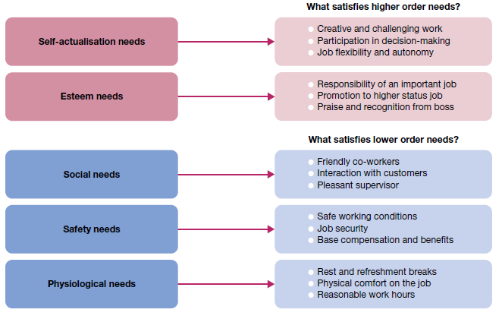

**Fig 3.2.1 Opportunities for satisfaction in Maslow’s hierarchy of human needs**

***b. ERG theory***

The existence, relatedness and growth (ERG) theory proposed by Clayton Alderfer, collapses Maslow’s five needs categories into three. *Existence needs* are desires for physiological and material wellbeing. *Relatedness needs* are desires for satisfying interpersonal relationships. *Growth needs* are desires for continued psychological growth and development. Alderfer’s ERG theory also differs from Maslow’s theory in other respects. This theory does not assume that lower level needs must be satisfied before higher level needs become activated. According to ERG theory, any or all of these three types of needs can influence individual behaviour at a given time. Alderfer also does not assume that satisfied needs lose their motivational impact. ERG theory thus contains a unique *frustration*–*regression principle*, according to which an already satisfied lower level need can become reactivated and influence behaviour when a higher level need cannot be satisfied. Alderfer’s approach offers an additional means for understanding human needs and their influence on people at work.

***c. Two-factor theory***

Another framework for understanding the motivational implications of work environments is the two-factor theory of Frederick Herzberg. The theory was developed from a pattern identified in the responses of almost 4000 people to questions about their work. When questioned about what ‘turned them on’, they tended to identify things relating to the nature of the job itself. Herzberg calls these **satisfier factors**. When questioned about what ‘turned them off’, they tended to identify things relating more to the work setting. Herzberg calls these **hygiene factors**.

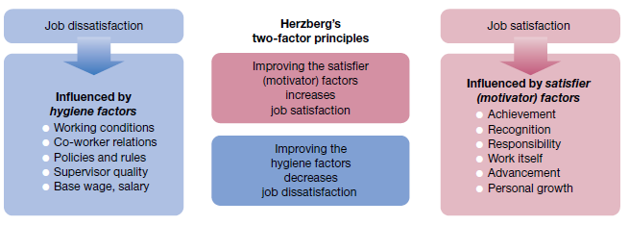

**Fig 3.2.2. Herzberg’s two-factor theory**

***d. Acquired needs theory***

McClelland identified three needs that are central to his approach to motivation. **Need for achievement (nAch)** is the desire to do something better or more efficiently, to solve problems, or to master complex tasks. **Need for power (nPower)** is the desire to control other people, to influence their behaviour, or to be responsible for them. **Need for affiliation (nAff)** is the desire to establish and maintain friendly and warm relations with other people.

According to McClelland, people acquire or develop these needs over time as a result of individual life experiences. In addition, he associates each need with a distinct set of work preferences. Managers are encouraged to recognise the strength of each need in themselves and in other people. Attempts can then be made to create work environments responsive to them. People high in the need for achievement, for example, like to put their competencies to work, take moderate risks in competitive situations and are willing to work alone. As a result, the work preferences of people with a high need for achievement include individual responsibility for results, achievable but challenging goals and feedback on performance.

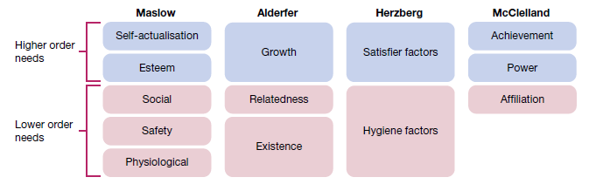

**Fig 3.2.3 Comparison of Maslow’s, Alderfer’s, Herzberg’s and McClelland’s motivation theories**

Additional Motivation Theories:

**McGregor ‘s Theory X and Theory Y**

Douglas McGregor, the eminent social psychologist, divides management style into two contrasting theories −

Theory X

This theory believes that employees are naturally unmotivated and dislike working, and this encourages an authoritarian style of management. According to this theory, management must firmly intervene to get things done. This style of management concludes that workers −

* Disfavor working.
* Abstain responsibility and the need to be directed.
* Need to be controlled, forced, and warned to deliver what's needed.
* Demand to be supervised at each and every step, with controls put in place.
* Require to be attracted to produce results, else they have no ambition or incentive to work.

McGregor observed that X-type workers are in fact mostly in minority, and yet in mass organizations, such as large scale production environment, X Theory management may be needed and can be unavoidable.

Theory Y

This theory explains a participative style of management, that is, distributive in nature. It concludes that employees are happy to work, are self-motivated and creative, and enjoy working with greater responsibility. It estimates that workers −

* Take responsibility willingly and are encouraged to fulfill the goals they are given.
* Explore and accept responsibility and do not need much guidance.
* Assume work as a natural part of life and solve work issues imaginatively.

In Y-type organizations, people at lower levels are engaged in decision making and have more responsibility.

**Comparing Theory X & Theory Y**

*Motivation*

Theory X considers that people dislike work, they want to avoid it and do not take responsibilities willingly.

While, Theory Y considers that people are self-motivated, and sportingly take responsibilities.

*Management Style and Control*

In Theory X-type organization, management is authoritarian, and centralized control is maintained.

While in Theory Y-type organization, the management style is participative, employees are involved decision making, but the power retains to implement decisions.

*Work Organization*

Theory X employees are specialized and the same work cycle continues.

In Theory Y, the work tends to be coordinated around wider areas of skill or knowledge. Employees are also motivated to develop expertise, and make suggestions and improvements.

*Rewards and Appraisals*

Theory X-type organizations work on a ‘carrot and stick’ basis, and performance assessment is part of the overall mechanism of control and compensation.

Coming to Theory Y-type organizations, appraisal is also regular and crucial, but is usually a separate mechanism from organizational controls. Theory Y-type organizations provide employees frequent opportunities for promotion.

Application

## 3.3 Leadership

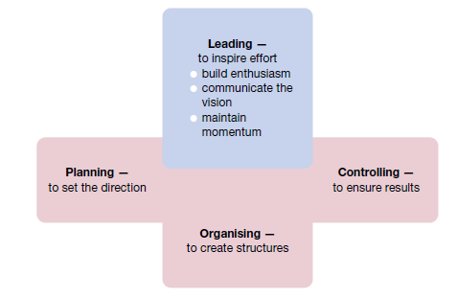

**Fig 3.3.1 Leading viewed in relationship to the other management functions**

**3.3.1 Traits of an ethical leader**

***The personality to defy groupthink***

Good leaders display intelligence and imagination to create a compelling vision of the future, and bring those who can deliver it with them. A good leader must be trustworthy and display unshakeable integrity, be action-oriented, resilient in the face of setbacks while treating people with respect, not as mere units of production. They have rid themselves of delusion and are brutally honest with themselves, know when to take risks and when to play it safe. Leaders are courageous, defy groupthink and accept the backlash against their unorthodox practices.

***The ability to set a good example***

A defining feature of the ethical leader is that in addition to the foundational qualities mentioned above, setting a consistently good example for others to follow. They have created a moral matrix that people internalise and operate from day to day.

***Selflessness***

Ethical leaders are strong when it comes to selfless service in the interests of the greater good.

***They’re not afraid to be challenged***

Having one’s subordinates call you out, disagree with you, challenge your judgement; all of this calls for great understanding and tolerance. Ethical leaders understand that it’s part of a culture of continuous improvement.

***They take responsibility for everything***

The ethical leader accepts that they are either directly or indirectly responsible for everything that happens in the organisation. They understand that blame shifting and finger pointing is a failure of leadership. The ethical leader does not resort to the ‘plausible deniability’ defence. Ultimately, good ethics is good business.

**3.3.2 The nature of leadership**

***Leadership and vision***

Today, leadership is often associated with **vision** — a future that you hope to create or achieve in order to improve on the present state of affairs. Truly great leaders are extraordinarily good at turning their visions into concrete results. Importantly, this involves the essential ability to communicate your vision in such a way that others commit their hard work to its fulfillment. .

***Power and influence***

The foundations of effective leadership lie in the way a manager uses power to influence the behavior of other people. Power is the ability to get someone else to do something you want done. It is the ability to make things happen the way you want them to. Need for power should not be a desire to control for the sake of personal satisfaction; it is a desire to influence and control others for the good of the group or organisation as a whole.

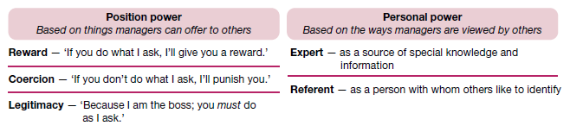

**Fig 3.3.2 Sources of position power and personal power used by managers**

***Sources of position power***

One important source of power is a manager’s official status, or position, in the organisation’s hierarchy of authority. Whereas anyone holding a managerial position theoretically has this power, how well it is used will vary from one person to the next. Consequently, leadership success will vary as well. The three bases of *position power* are reward power, coercive power and legitimate power.

**Reward power** is the ability to influence through rewards. It is the capacity to offer something of value — a positive outcome — as a way of influencing the behaviour of other people. This involves the control of rewards or resources such as pay rises, bonuses, promotions, special assignments and verbal or written compliments.

**Coercive power** is the ability to influence through punishment. It is the capacity to punish or withhold positive outcomes as a way of influencing the behaviour of other people. A manager may try to coerce someone by threatening him or her with verbal reprimands, pay penalties and even termination.

**Legitimate power** is the ability to influence through authority — the right by virtue of organizational position or status to exercise control over people in subordinate positions.

**Sources of personal power**

**Expert power** is the ability to influence through special expertise. It is the capacity to influence the behaviour of other people because they recognise your knowledge, understanding and skills. Expertise derives from the possession of technical know-how or information pertinent to the issue at hand. This is developed by acquiring relevant skills or competencies or by gaining a central position in relevant information networks.

**Referent power** is the ability to influence through identification. It is the capacity to influence the behaviour of other people because they admire you and want to identify positively with you. Reference is a power derived from charisma or interpersonal attractiveness. It is developed and maintained through good interpersonal relations that encourage the admiration and respect of others.

**Turning power into influence**

The best leaders and managers understand that different outcomes are associated with use of the various power bases. When a leader relies on rewards and legitimacy to influence others, the likely outcome is temporary compliance. When a leader relies on coercion to gain influence, compliance also depends on the continued threat of punishment. In this case, however, the compliance is very temporary and often accompanied by resistance. Use of expert and referent power creates the most enduring influence; they create commitment. Followers respond positively because of internalised understanding or beliefs that create their own long‐lasting effects on behaviour. Position power alone is often insufficient to achieve and sustain needed influence. Personal power and the bases of expert and referent power often make the difference between leadership success and mediocrity. Four points to keep in mind are: (1) there is no substitute for expertise; (2) likeable personal qualities are very important; (3) effort and hard work breed respect; and (4) personal behaviour must support expressed values.

**Ethics and the limits to power**

Four conditions that determine whether a leader’s directives will be followed and true influence achieved.

* The other person must truly understand the directive.
* The other person must feel capable of carrying out the directive.
* The other person must believe that the directive is in the organisation’s best interests.
* The other person must believe that the directive is consistent with personal values.

**Leadership and empowerment**

**Empowerment** is the process through which managers enable others to gain power and achieve influence within the organisation. Effective leaders empower others by providing them with the information, responsibility, authority and trust to make decisions and act independently within their areas of expertise. They know that when people feel empowered to act, they tend to follow through with commitment and high‐quality work. They also realise that power in organisations is not a ‘zero‐sum’ quantity. That is, in order for someone to gain power, it isn’t necessary for someone else to give it up.

**3.3.3 Leadership traits and behaviours**

Shelley Kirkpatrick and Edwin Locke identify these personal traits as being common among successful leaders.

* *Drive*. Successful leaders have high energy, display initiative and are tenacious.
* *Self-confidence*. Successful leaders trust themselves and have confidence in their abilities.
* *Creativity*. Successful leaders are creative and original in their thinking.
* *Cognitive ability*. Successful leaders have the intelligence to integrate and interpret information.
* *Business knowledge*. Successful leaders know their industry and its technical foundations.
* *Motivation*. Successful leaders enjoy influencing others to achieve shared goals.
* *Flexibility*. Successful leaders adapt to fit the needs of followers and the demands of situations.
* *Honesty and integrity*. Successful leaders are trustworthy; they are honest, predictable and dependable.

**Focus on leadership behaviours**

Recognising that the possession of certain traits alone is not a guarantee of leadership success, *behavioural theories of leadership*, work to determine which **leadership style** — the recurring pattern of behaviours exhibited by a leader — worked best. If the preferred style could be identified, the implications were straightforward and practical — train leaders to become skilled at using the ideal style to best advantage. Most research in the leader behaviour tradition focused on two dimensions of leadership style: concern for the task to be accomplished and concern for the people doing the work. Concern for task is sometimes called *initiating structure, job-centredness* and *task orientation*; concern for people is sometimes called *consideration, employee-centredness* and *relationship orientation*. *A leader high in concern for task* plans and defines work to be done, assigns task responsibilities, sets clear work standards, urges task completion and monitors performance results. In contrast, *a leader high inconcern for people* acts in a manner that is warm and supportive towards followers, maintains good social relations with them, respects their feelings, is sensitive to their needs and shows trust in them. The results of leader behaviour research at first suggested that followers of people oriented leaders were more productive and satisfied than those working for more task oriented leaders. Later results, however, suggested that truly effective leaders were high in both concern for people and concern for task.

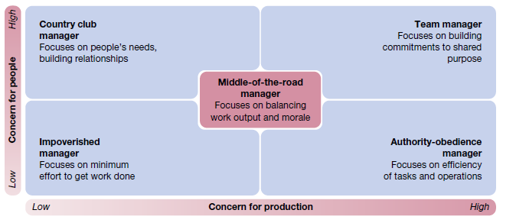

**Fig 3.3.3 Managerial styles in Blake and Mouton’s Leadership Grid**

**3.3.4 Issues in leadership development**

**Transformational leadership**

The term **transformational leadership** describes someone who is truly inspirational as a leader and who arouses others to seek extraordinary performance accomplishments. The late Steve Jobs, mentioned in the technology box in this chapter, exemplifies such a leader. A transformational leader uses charisma and related qualities to raise aspirations and shift people and organisational systems into new high‐performance patterns. Scholars differentiate this from **transactional leadership**, which describes someone who is more methodical in keeping others focused on progress towards goal accomplishment. A transactional leader adjusts tasks, rewards and structures to move followers towards accomplishing organisational objectives.

The special qualities that are often characteristic of such transformational leaders include the following:

* *vision* — having ideas and a clear sense of direction; communicating them to others; developing excitement about accomplishing shared ‘dreams’
* *charisma* — arousing others’ enthusiasm, faith, loyalty, pride and trust in themselves through the power of personal reference and appeals to emotion
* *symbolism* — identifying ‘heroes’, offering special rewards and holding spontaneous and planned ceremonies to celebrate excellence and high achievement
* *empowerment* — helping others develop, removing performance obstacles, sharing responsibilities and delegating truly challenging work
* *intellectual stimulation* — gaining the involvement of others by creating awareness of problems and stirring their imagination to create high‐quality solutions
* *integrity* — being honest and credible, acting consistently out of personal conviction and following through commitments

**Emotional intelligence**

An area of leadership development currently very popular is **emotional intelligence**, emotional intelligence is defined as ‘the ability to manage ourselves and our relationships effectively’. A leader’s emotional intelligence is an important influence on his or her effectiveness, especially in more senior management positions.

The critical components of emotional intelligence are the following.

i. *Self-awareness* is an ability to understand our own moods and emotions, and understand their impact on our work and on others.

ii. *Self-regulation* is the ability to think before we act and to control otherwise disruptive impulses.

iii. *Motivation* is the ability to work hard with persistence and for reasons other than money and status.

iv. *Empathy* is the ability to understand the emotions of others and to use this understanding to better relate to them.

v. *Social skill* is the ability to establish rapport with others and to build good relationships and networks.

**Gender and leadership**

The evidences clearly supports that both women and men can be effective leaders. Women may tend towards a style sometimes referred to as interactive leadership. This style focuses on the building of consensus and good interpersonal relations through communication and involvement. Leaders of this style display behaviours typically considered democratic and participatory — such as showing respect for others, caring for others, and sharing power and information with others. This interactive style also has qualities in common with the transformational leadership just discussed. Men, on the other hand, may tend towards more of a transactional approach to leadership — relying more on directive and assertive behaviours, and using authority in a traditional ‘command and control’ sense.

Given the emphasis on shared power, communication, cooperation and participation in the new form organisations of today, these results are provocative. Gender issues aside, the interactive leadership style seems to be an excellent fit with the demands of a diverse workforce and the new workplace. Regardless of whether the relevant behaviours are displayed by women or men, it seems clear that future leadership success will rest more often on capacity to lead through positive relationships and empowerment than through aloofness and formal authority.

**Drucker’s ‘oldfashioned’ leadership**

Peter Drucker offers another very pragmatic approach to leadership in the new workplace. It is based on what he refers to as a ‘good old-fashioned’ view of the plain hard work it takes to be a successful leader. He said, ‘leadership . . . is work’. He identifies the following three essentials of leadership. First, *defining and establishing a sense of mission.* Second, *accepting leadership as a responsibility rather than a rank*. Third, *earning and keeping the trust of others*. ‘Effective leadership . . . is not based on being clever; it is based primarily on being consistent’.

**Moral leadership**

Society expects organisations to be run with **moral leadership**. This is leadership by ethical standards that clearly meet the test of being ‘good’ and ‘correct’. The expectation is that anyone in a leadership position will practise high ethical standards of behaviour, help to build and maintain an ethical organisational culture, and both help and require others to behave ethically in their work. Another is the notion of **authentic leadership.** An authentic leader has a high level of selfawareness and clearly understands his or her personal values. This leader also acts consistent with those values, being honest and avoiding self‐deceptions. The result is positive self regulation that helps authentic leaders clearly frame moral dilemmas, transparently respond to them, and consistently serve as ethical role models.

## 3.4 Organising

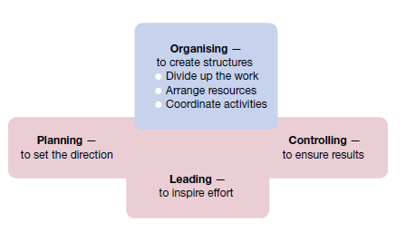

**Fig 3.4.1 Organising viewed in relationship with the other management functions**

Organizations are systems created to achieve common goals through people-to-people and people-to-work relationships. They are essentially social entities that are goal-directed, deliberately structured for coordinated activity systems, and is linked to the external environment. Organizations are made up of people and their relationships with one another. Managers deliberately structure and coordinate organizational resources to achieve the organization’s purpose.

Each organization has its own external and internal environments that define the nature of the relationships according to its specific needs. Organizing is the function that managers undertake to design, structure, and arrange the components of an organization’s internal environment to facilitate attainment of organizational goals.

Organizing creates the framework needed to reach a company's objectives and goals.

Organizing is the process of defining and grouping activities, and establishing authority relationships among them to attain organizational objectives.

## Importance of Organizing

A comprehensive approach to organizing helps the management in many ways. Organizing aligns the various resources towards a common mission.

### Efficient Administration

It brings together various departments by grouping similar and related jobs under a single specialization. This establishes coordination between different departments, which leads to unification of effort and harmony in work.

It governs the working of the various departments by defining activities and their authority relationships in the organizational structure. It creates the mechanism for management to direct and control the various activities in the enterprise.

### Resource Optimization

Organizing ensures effective role-job-fit for every employee in the organization. It helps in avoiding confusion and delays, as well as duplication of work and overlapping of effort.

### Benefits Specialization

It is the process of organizing groups and sub-divide the various activities and jobs based on the concept of division of labor. This helps in the completion of maximum work in minimum time ensuring the benefit of specialization.

### Promotes Effective Communication

Organizing is an important means of creating coordination and communication among the various departments of the organization. Different jobs and positions are interrelated by structural relationship. It specifies the channel and mode of communication among different members.

### Creates Transparency

The jobs and activities performed by the employees are clearly defined on the written document called **job description** which details out what exactly has to be done in every job. Organizing fixes the authority-responsibility among employees. This brings in clarity and transparency in the organization.

### Expansion and Growth

When resources are optimally utilized and there exists a proper division of work among departments and employees, management can multiply its strength and undertake more activities. Organizations can easily meet the challenges and can expand their activities in a planned manner.

## Principles of Organizing

## Work Specialization

Also called **division of labor**, work specialization is the degree to which organizational tasks are divided into separate jobs. Each employee is trained to perform specific tasks related to their specialized function.

Specialization is extensive, for example running a particular machine in a factory assembly line. The groups are structured based on similar skills. Activities or jobs tend to be small, but workers can perform them efficiently as they are specialized in it.

## Authority

Authority is the legitimate power assigned to a manager to make decisions, issue orders, and allocate resources on behalf of the organization to achieve organizational objectives.

Authority is within the framework of the organization structure and is an essential part of the manager’s job role. Authority follows a top-down hierarchy. Roles or positions at the top of the hierarchy are vested with more formal authority than are positions at the bottom.

## Chain of Command

The chain of command is an important concept to build a robust organization structure. It is the unbroken line of authority that ultimately links each individual with the top organizational position through a managerial position at each successive layer in between.

It is an effective business tool to maintain order and assign accountability even in the most casual working environments. A chain of command is established so that everyone knows whom they should report to and what responsibilities are expected at their level. A chain of command enforces responsibility and accountability. It is based on the two principles of **Unity of command** and **Scalar Principle**.

## Delegation

Another important concept closely related to authority is delegation. It is the practice of turning over work-related tasks and/or authority to employees or subordinates. Without delegation, managers do all the work themselves and underutilize their workers. The ability to delegate is crucial to managerial success.

Delegation as a process involves establishment of expected outcomes, task assignment, delegation of authority for accomplishing these tasks, and exaction of responsibility for their accomplishment. Delegation leads to empowerment, as employees have the freedom to contribute ideas and do their jobs in the best possible ways.

## Span of Control

Span of control (also referred to as Span of Management) refers to the number of employees who report to one manager. It is the number of direct reportees that a manager has and whose results he is accountable for.

Span of control is critical in understanding organizational design and the group dynamics operating within an organization. Span of control may change from one department to another within the same organization.

**3.4.1 Organisational structure**

The organisational structure is the system of tasks, workflows, reporting relationships and communication channels that link the work of diverse individuals and groups. Any structure should both allocate task assignments, through a division of labour, and provide for the coordination of performance results. A good structure that does both of these things well can be an important asset to an organisation. However, there is no structure that meets the needs of all circumstances. Structure must be handled in a contingency fashion; as environments and situations change, structures must often be changed too. To make good choices, a manager must know the alternatives and be familiar with current trends and developments. They must also be prepared to create ‘chaos’ to help produce innovative solutions to complex problems, when necessary. Nothing new and innovative can emerge from organising systems that are highly ordered and stable. Chaotic systems, such as revolutions and resistance, create new configurations of decision making and power.

**Formal structure**

The concept of structure is known best in the form of an **organisation chart**, which is a diagram that shows reporting relationships and the formal arrangement of work positions within an organisation. A typical organisation chart identifies various positions and job titles, as well as the lines of authority and communication between them. This is the *formal structure*, or the structure of the organisation in its official state. It represents the way the organisation is intended to function.

**Informal structure**

Behind every formal structure typically lies an **informal structure**. This is a ‘shadow’ organization made up of the unofficial, but often critical, working relationships between organisational members. If the informal structure could be drawn, it would show who talks to and interacts regularly with whom, regardless of their formal titles and relationships. The lines of the informal structure would cut across levels and move from side to side. Importantly, no organisation can be fully understood without first gaining insight into the informal structure, as well as the formal one. Informal structures can be very helpful in getting needed work accomplished in any organisation.

Through the emergent and spontaneous relationships of informal structures, people gain access to interpersonal networks of emotional support and friendship that satisfy important social needs. They also benefit in task performance, by being in personal contact with others who can help them get things done when necessary. *Informal learning* is increasingly recognized as an important resource for organisational development. Of course, informal structures also have potential disadvantages. Because they exist outside the formal authority system, the activities of informal structures can sometimes work against the best interests of the organisation as a whole. They can also be susceptible to rumour, carry inaccurate information, breed resistance to change and even divert work efforts from important objectives.

**3.4.2 Traditional organisation structures**

A traditional principle of organising is that performance gains are possible when people are allowed to specialise and become experts in specific jobs or tasks. Given this division of labour, however, decisions must then be made on how to group work positions into formal teams or departments, and then link them together in a coordinated fashion within the larger organisation. These decisions involve a process called **departmentalisation**, which has traditionally resulted in three major types of organisation structures — the functional, divisional and matrix structures.

**Functional structures**

In **functional structures**, people with similar skills and performing similar tasks are formally grouped together into work units. Members of functional departments share technical expertise, interests and responsibilities. The first example in figure shows a common functional structure in a business. In this case, senior management includes the functions of marketing, finance, production and human resources. In this functional structure, manufacturing problems are the responsibility of the production director; marketing problems are the province of the marketing director, and so on.

The key point is that members of each function work within their areas of expertise. If each function works properly, the expectation is that the business will operate successfully. Functional structures are not limited to businesses. The figure also shows how this form of departmentalization can be used in other types of organisations, such as banks and hospitals. These types of structures typically work well for small organisations that produce only one or a few products or services. They also tend to work best in relatively stable environments, where problems are predictable and there are limited demands for innovation and change.

The major *advantages of functional structures* include the following:

* Economies of scale with efficient use of resources
* Task assignments consistent with expertise and training
* High quality technical problem‐solving
* Indepth training and skill development within functions
* Clear career paths within functions.

There are also potential *disadvantages of functional structures*. Common problems with functional structures involve difficulties in pinpointing responsibilities for things like cost containment, product or service quality, timeliness and innovation in response to environmental changes. Such problems with functional structures are magnified as organisations grow in size and environments begin to change. Another significant concern is often called the *functional chimneys problem,* refers to the lack of communication, coordination and problem solving across functions.

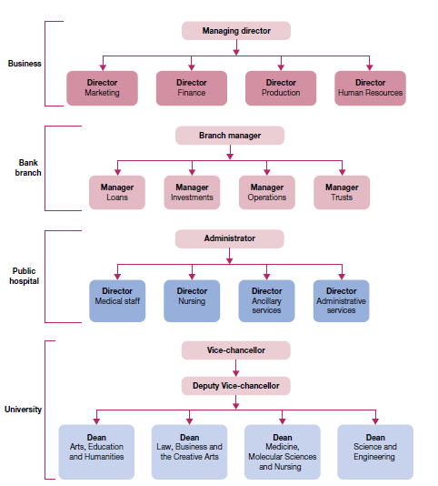

**Fig 3.4.2 Functional structures in a business, a bank branch, a public hospital and a university**

**Divisional structures**

**Divisional structure** groups together people who work on the same product or process, serve similar customers, and/or are located in the same area or geographical region. As illustrated in figure, divisional structures are common in complex organisations that have multiple and differentiated products and services, serve diverse customers, pursue diversified strategies, and/or operate in various and different competitive environments. The major types of divisional approaches are the product, geographical, customer and process structures.

Divisional structures attempt to avoid problems common to functional structures. They are especially popular among organisations with diverse operations that extend across many products, territories, customers and work processes.

The potential *advantages of divisional structures* include:

* More flexibility in responding to environmental changes
* Improved coordination across functional departments
* Clear points of responsibility for product or service delivery
* Expertise focused on specific customers, products and regions
* Greater ease in changing size by adding or deleting divisions.

There are also potential *disadvantages of divisional structures*. They can reduce economies of scale and increase costs, through the duplication of resources and efforts across divisions. They can also create unhealthy rivalries — as divisions compete for resources and attention, and they emphasise division needs and goals to the detriment of the goals of the organisation as a whole.

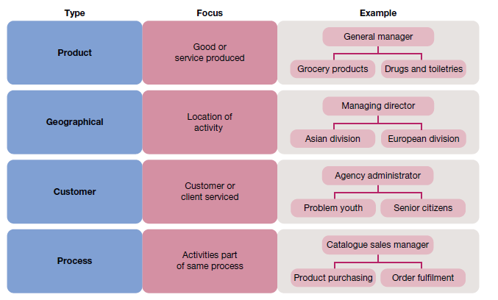

**Fig 3.4.3 Divisional structures based on product, geography, customer and process**

**Product structures**

**Product structures** group together jobs and people working on a single product or service. They clearly identify costs, profits, problems and successes in a market area with a central point of accountability. Consequently, managers are encouraged to be responsive to changing market demands and customer tastes. Common in large organisations, product structures may even extend into global operations. Product structures are becoming less common in major companies, as many companies are constantly trying to innovate and create new products. Heinz, Intel and Apple have all moved away from product structures in recent years.

**Geographical structures**

**Geographical structures** group together jobs and activities being performed in the same location or geographical region. They are typically used when there is a need to differentiate products or services in various locations, such as in different regions of a country. They are also quite common in international operations, where they help to focus attention on the unique cultures and requirements of particular regions

**Customer structures**

**Customer structures** group together people and jobs that are serving the same customers or clients. The major appeal is the ability to serve the special needs of the different customer groups. With increasing differentiation of global markets, this structure is often well suited to complex businesses.

**Process structures**

A *work process* is a group of tasks related to one another that collectively create something of value to a customer. An example is order fulfilment — when you email a catalogue retailer and request a particular item. The process of order fulfilment takes the order from point of initiation by the customer to point of fulfilment by a delivered order. **Process structures** group together jobs and activities that are part of the same processes. In the example in figure , this might take the form of product purchasing teams, order fulfilment teams and systems‐support teams for the mail‐order catalogue business.

**Matrix structures**

The **matrix structure**, often called the *matrix organisation*, combines the functional and divisional structures, it is an attempt to gain the advantages and minimise the disadvantages of each. This is accomplished in the matrix by using permanent cross‐functional teams to integrate functional expertise, in support of a clear divisional focus on a product, project or program. As shown figure, workers in a matrix structure belong to at least two formal groups at the same time — a functional group and a product, program or project team. They also report to two bosses — one within the function and the other within the team.

The matrix organisation has gained a strong foothold in the workplace, with applications in diverse settings, such as manufacturing (e.g. aerospace, electronics, pharmaceuticals), service industries (e.g. banking, brokerage, retailing), professional fields (e.g. accounting, advertising, law) and the not for profit sector (e.g. city, state and federal agencies; hospitals; universities). Matrix structures are also in multinational organisations, in which they offer the flexibility to deal with both regional differences and multiple product, program or project needs. Matrix structures are common in organisations pursuing growth strategies in dynamic and complex environments.

The main contribution of matrix structures to organisational performance lies in the use of permanent cross functional teams. Team members work closely together, and in a timely manner, to share expertise and information to solve problems. The potential *advantages of matrix structures* include:

* Better inter functional cooperation in operations and problem solving
* Increased flexibility in adding, removing and/or changing operations to meet changing demands
* Better customer service, since there is always a program, product or project manager informed and available to answer questions
* Better performance accountability through the program, product or project managers
* Improved decision‐making, as problem‐solving takes place at the team level — where the best information is available
* Improved strategic management, since top managers are freed from unnecessary problem solving and can focus on strategic issues.

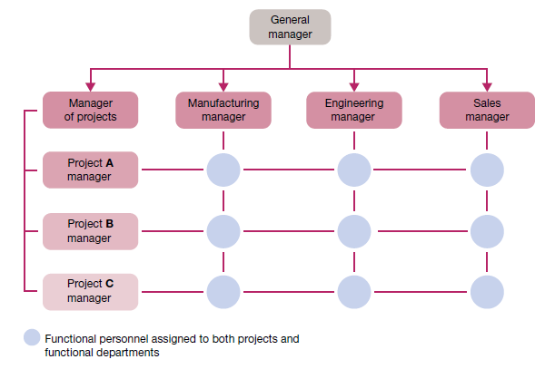

**Fig 3.4.4 Matrix structure in a small multi project business**

There are also potential *disadvantages of matrix structures*. The two‐boss system is susceptible to power struggles, as functional supervisors and team leaders vie with one another to exercise authority. The two‐boss system can also be frustrating for matrix members, if it creates task confusion and conflicts in work priorities. Team meetings in the matrix are also time consuming. Teams may develop ‘groupitis’, or strong team loyalties that cause a loss of focus on larger organizational goals, and the requirements of adding the team leaders to a matrix structure can result in increased costs.

## 3.5 Essentials of organisational design

**Organisational design** is the process of choosing and implementing structures that best arrange resources to serve the organisation’s mission and objectives. The ultimate purpose of organizational design is to create an alignment between supporting structures and situational challenges. As shown in figure, this includes taking into consideration the implications of environment, strategies, people, technology and size. Importantly, the process of organisational design is a problem solving activity that should be approached in a contingency fashion that takes all of these factors into account. There is no universal design that applies in all circumstances. The goal is to achieve a best fit between the structure and the unique situation faced by each organisation. In the contemporary global economy, one of the key developments in organisational design is the emergence of the virtual organisation.

The idea of a deliberately formless and fluid organisation might seem at odds with notions of organisational design. However, virtual organisations are the antithesis of the rigid hierarchies and bureaucracies that often characterise conventional organisations. Key directions for changes in organisations today involve a basic shift in attention — from a traditional emphasis on more vertical or authority‐driven structures to an emphasis on structures that are more horizontal and task driven. In management theory, these developments are framed by the distinction between bureaucratic designs that are mechanistic and vertical in nature, and adaptive designs that are more organic and horizontal in nature. This distinction itself is viewed from the contingency position that there is no one best way to organise, and that the choice of organisational design should always achieve the best fit with situational needs.

**Bureaucratic designs**

A *bureaucracy* can be described as a form of organisation based on logic, order and the legitimate use of formal authority. Its distinguishing features include a clear‐cut division of labour, a strict hierarchy of authority, formal rules and procedures, and promotion based on competency. Bureaucracies are supposed to be orderly, fair and highly efficient. Yet, the term ‘bureaucracy’ today, has a negative connotation. Instead of operating efficiency, the bureaucracies that we know are often associated with ‘red tape’. Instead of being orderly and fair, they are often cumbersome and impersonal, to the point of insensitivity to customer or client needs.

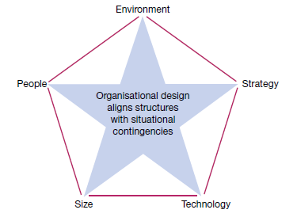

**Fig 3.5.1 A framework for organisational design — aligning structures with situational contingencies**

Instead of viewing all bureaucratic structures as inevitably flawed, management theory takes a contingency perspective. When is a bureaucratic form a good choice for an organisation? What alternatives exist when it is not a good choice?

Two quite different organisational forms could be successful, with the choice between them depending on the nature of an organisation’s external environment. A more bureaucratic form, called a *mechanistic approach*, thrived when the environment was stable, but experienced difficulty when the environment was rapidly changing and uncertain. In these dynamic situations, a much less bureaucratic form, called an *organic approach*, performed best.

Organisations that operate with highly **mechanistic designs** are very bureaucratic in nature. As shown in the figure, they typically operate with more centralised authority, many rules and procedures, a precise division of labour, narrow spans of control and formal means of coordination. Mechanistic designs are described as ‘tight’ structures of the traditional vertical or pyramid form. An example is your local KFC or McDonald’s. A relatively small operation, each store operates quite like others in the franchise chain and according to rules established by the corporate management. Service personnel work in orderly and disciplined ways, guided by training, rules and procedures, and with close supervision by crew leaders who work alongside them. Even the appearance of service personnel is carefully regulated, with everyone working in a standard uniform. These restaurants perform well, as they repetitively deliver items that are part of their standard menus. You quickly encounter the limits, however, if you try to order something not on the menu. The servers do not prepare anything out of the ordinary. The chains also encounter difficulty when consumer tastes change or take on regional preferences that are different from what the corporate menu provides. Adjustments to the system are typically a long time coming.

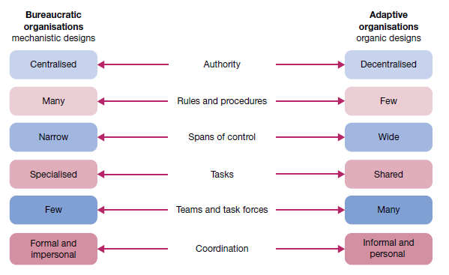

**Fig 3.5.2 A continuum of organisational design alternatives — from bureaucratic to adaptive organizations**

**Adaptive designs**

A technology company, consumer products firm, financial services business or dot com retailer make continual adjustments to its operations and organisational design. Enlightened managers are helping organizations reconfigure into new forms that emphasise flexibility and speed, while retaining sight of important performance objectives. The organisational design trend now is towards more **adaptive organisations** that operate with a minimum of bureaucratic features and with cultures that encourage worker empowerment and participation. Such organisations display features of the **organic designs** portrayed in figure , including more decentralised authority, fewer rules and procedures, less precise division of labour, wider spans of control and more personal means of coordination. They are described as relatively loose systems in which a lot of work is done through informal structures and networks of interpersonal contacts. Organic designs recognise and legitimise these links, and give them the resources they need to operate best. Adaptive organisations are built on trusting that people will do the right things on their own initiative. They move organisational design in the direction of what some might call *self organisation*, where the focus is on freeing otherwise capable people from unnecessarily centralised control and restrictions.

**Virtual designs**

A number of common features define virtual organisations. First, the lack of physical structure compared with conventional organisations means there are fewer tangible assets, such as office buildings, warehouses and fleet vehicles. Organisations are emerging that are structured entirely in virtual reality, with computer links replacing physical infrastructure, so that companies exist only in cyberspace. Second, electronic communications technologies — the internet, social media platforms, instant and text messaging, and other forms of electronic communication — form the basis of the virtual organisation, linking people, assets, knowledge and ideas. A third feature of the virtual organisation is mobility of work. Communication networks, rather than buildings and physical assets, become the ‘workspace’ for organizational members. A fourth feature of virtual organisations is their hybrid nature. They can consist of a loose framework of human resources, assets and knowledge involving organisational units, a consortia of companies, and autonomous members brought together for a given time period to achieve a mutual objective.

Once the objective is achieved, the virtual organisation either ceases to exist or reconfigures itself to tackle the next goal. These hybrids can be short term but also long‐term if they are tackling difficult research or infrastructure projects, or are part of an ongoing supply chain. A fifth and related feature is their lack of boundaries and inclusiveness. Virtual organisations are not constrained by what is traditionally thought of as an individual company or corporation and how they are legally defined. Virtual organisations often encompass suppliers and distributors to such an extent that it is difficult to unravel where one company ends and the other begins. Finally, virtual organisations embody flexibility, through their ability to restructure and to redeploy assets to meet changing requirements.

**3.5.2 Contingencies in organisational design**

The contingency factors in the organisational design are the environment, strategy, technology, size and life cycle, human resources and restructuring.

**Environment**

The organisation’s external environment and the degree of uncertainty it offers are of undeniable importance in organisational design.A *certain environment* is composed of relatively stable and predictable elements. Bureaucratic organisations and mechanistic designs are quite adequate under such conditions. An *uncertain environment* will have more dynamic and less predictable elements. This requires more adaptive organizations and organic designs.

**Strategy**

The nature of organisational strategies and objectives influence the choice of structure, structure follows strategy. When strategy is stability oriented, the choice of organisational design should be based on the premise that little significant change will be occurring in the external environment. This means that plans can be set and operations programmed to be routinely implemented. To best support this strategic approach, the organisation should be structured to operate in well defined and predictable ways. This is most characteristic of bureaucratic organisations that use more mechanistic design alternatives. When strategy is growth oriented and likely to change frequently, the situation as a whole becomes more complex, fluid and uncertain. Operating objectives are likely to include the need for innovation and flexible responses to changing competition in the environment. Operations and plans are likely to have short life spans, and require frequent and even continuous modification over time. The most appropriate structure is one that allows for internal flexibility and freedom to create new ways of doing things.

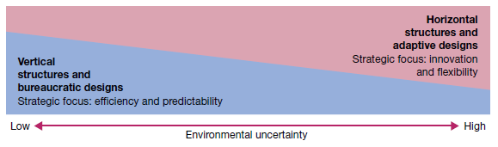

**Fig 5.5.3 Environmental uncertainty and the performance of vertical and horizontal designs**

**Size and life cycle**

Organisational size, typically measured by number of employees, is another contingency factor in organizational design. Larger organisations tend to have more mechanistic structures than smaller ones, it is clear that this is not always best for them. Organisations tend to become more bureaucratic as they grow in size and consequently have more difficulty adapting to changing environments. It is especially important to understand the design implications of the **organisational life cycle**, or the evolution of an organisation over time through different stages of growth.

The stages in the organizational life cycle can be described as:

i. *birth stage* — when the organisation is founded by an entrepreneur

ii. *youth stage* — when the organisation starts to grow rapidly

iii. *midlife stage* —when the organisation has grown large with success

iv. *maturity stage* — when the organisation stabilises at a large size.

In its *birth stage*, the founder usually runs the organisation. It stays relatively small, and the tructure is quite simple. The organisation starts to grow rapidly during the *youth stage* and management responsibilities extend among more people. An organisation in the *midlife stage* is even larger, with a more complex and increasingly formal structure. More levels appear in the chain of command, and the founder may have difficulty remaining in control. In the *maturity stage*, the organization stabilises in size, typically with a mechanistic structure. It runs the risk of becoming complacent and slow in competitive markets. One way of coping with the disadvantages of large size is downsizing; that is, taking action to reduce the scope of operations and number of employees. This response is often used when top management is challenged to reduce costs quickly and to increase productivity. Downsizing is often associated with decreases in subsequent firm profitability, and that research and development industries in particular may suffer many negative effects from downsizing.

**Human resources**

A good organisational design provides people with the supporting structures they need to achieve both high performance and satisfaction in their work. Modern management theory views people–structure relationships in a contingency fashion. There should be a good ‘fit’ between organisation structures and the human resources. An important human resource issue in organisational design is skill. Any design should allow the expertise and talents of organisational members to be realised to the full.

**Additional Learning**

**2. Process theories of motivation**

***a. Equity theory***

The equity theory of motivation is is based on the logic of social comparisons and the notion that perceived inequity is a motivating state. That is, when people believe that they have been unfairly treated in comparison to others, they will be motivated to eliminate the discomfort and restore a perceived sense of equity to the situation.

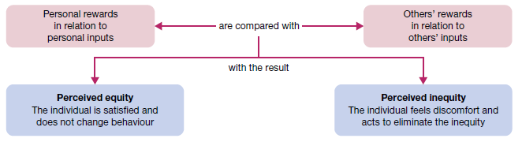

**Fig 3.2.4 Equity theory and the role of social comparison**

Adams (Equity theory is known by his works) predicts that people will try to deal with perceived negative inequity, the case where the individual feels disadvantaged in comparison with others, by:

* Changing their work inputs by putting less effort into their jobs
* Changing the rewards received by asking for better treatment
* Changing the comparison points to make things seem better
* Changing the situation by leaving the job.

***b. Expectancy theory***

The expectancy theory of motivation by Victor Vroom asks a central question: What determines the willingness of an individual to work hard at tasks important to the organisation? In response to this question, expectancy theory suggests that ‘people will do what they can do when they want to do it’. More specifically, Vroom suggests that the motivation to work depends on the relationships between the *three expectancy factors*

* **Expectancy** is a person’s belief that working hard will result in a desired level of task performance being achieved (this is sometimes called effort–performance expectancy).
* **Instrumentality** is a person’s belief that successful performance will be followed by rewards and other potential outcomes (this is sometimes called performance–outcome expectancy).
* **Valence** is the value a person assigns to the possible rewards and other work‐related outcomes.

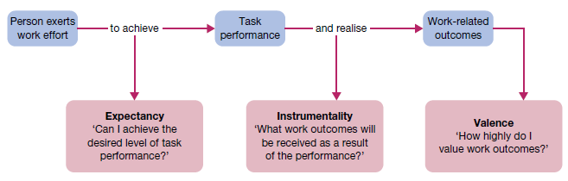

**Fig 3.2.5 Elements in the expectancy theory of motivation**

Expectancy theory posits that motivation (*M*), expectancy (*E*), instrumentality (*I*) and valence (*V*) are related to one another in a multiplicative fashion: *M* = *E* × *I* × *V*. In other words, motivation is determined by expectancy times instrumentality times valence. This multiplier effect among the expectancy factors has important managerial implications. Mathematically speaking, a zero at any location on the right-hand side of the equation (that is, for *E*, *I* or *V*) will result in zero motivation. Managers are thus advised to act in ways that maximise all three components of the equation — expectancy (people must believe that if they try they can perform), instrumentality (people must perceive that high performance will be followed by certain outcomes) and valence (people must value the outcomes). Not one of these factors can be left unattended.

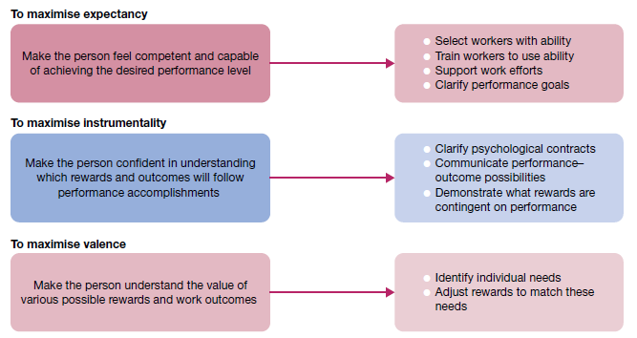

**Fig 3.2.6 Managerial implications of expectancy theory**

***c. Goal-setting theory***

Another process theory, as described by Edwin Locke, suggests task goals can be highly motivating — if they are properly set and if they are well managed. Goals give direction to people in their work. Goals clarify the performance expectations between a supervisor and subordinate, between co-workers, and across subunits in an organisation. Goals establish a frame of reference for task feedback. Goals also provide a foundation for behavioural self-management. In these and related ways, Locke believes goal setting can enhance individual work performance and job satisfaction.

***d.Self-efficacy theory***

Closely related to both the expectancy and goal-setting approaches to motivation is self-efficacy theory, also referred to as social learning theory. Based on the work of psychologist Albert Bandura, the notion of self-efficacy refers to a person’s belief that she or he is capable of performing a task. You can think of self-efficacy using terms such as confidence, competence and ability. From a manager’s perspective, the major insight of self-efficacy theory is that anything done to boost feelings of confidence, competence and ability among people at work is likely to pay off with increased levels of motivation.

**3. Reinforcement theory of motivation**

The content and process theories described so far use cognitive explanations of behaviour. They are concerned with explaining ‘why’ people do things in terms of satisfying needs, resolving felt inequities, and/or pursuing positive expectancies and task goals. Reinforcement theory, in contrast, views human behaviour as determined by its environmental consequences. Instead of looking within the individual to explain motivation and behaviour, it focuses on the external environment and the consequences it holds for the individual. The basic premises of the theory are based on what E. L. Thorndike called the **law of effect** — behaviour that results in a pleasant outcome is likely to be repeated; behaviour that results in an unpleasant outcome is not likely to be repeated.

**Reinforcement strategies**

Psychologist B. F. Skinner popularised the concept of **operant conditioning** as the process of applying the law of effect to control behaviour by manipulating its consequences. You may think of operant conditioning as learning by reinforcement. In management the term is often discussed with respect to **organisational behaviour modification (OB Mod)**, the application of operant conditioning techniques to influence human behaviour in the workplace. The goal of OB Mod is to use reinforcement principles to systematically reinforce desirable work behaviour and discourage undesirable work behaviour.

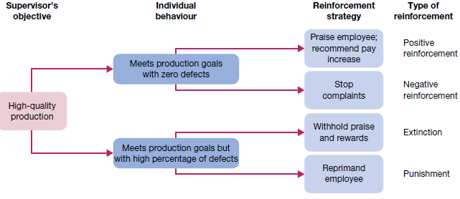

**Fig 3.2.7 Applying reinforcement strategies: case of total quality management**

Four strategies of reinforcement are used in operant conditioning. **Positive reinforcement** strengthens or increases the frequency of desirable behaviour by making a pleasant consequence contingent on its occurrence. **Negative reinforcement** increases the frequency of or strengthens desirable behaviour by making the avoidance of an unpleasant consequence contingent on its occurrence. **Punishment** decreases the frequency of or eliminates an undesirable behaviour by making an unpleasant consequence contingent on its occurrence. **Extinction** decreases the frequency of or eliminates an undesirable behaviour by making the removal of a pleasant consequence contingent on its occurrence.

**Ethical issues in reinforcement**

There debates over both the results and the ethics of controlling human behaviour. Opponents are concerned that use of operant conditioning principles ignores the individuality of people, restricts their freedom of choice and ignores the fact that people can be motivated by things other than externally administered rewards. Advocates, however, attack these criticisms. They agree that reinforcement involves the control of behaviour, but they argue that control is part of every manager’s job. The real question may not be whether it is ethical to control behaviour but whether it is ethical not to control behaviour well enough so that the goals of both the organisation and the individual are well served. Even as research continues, the value of reinforcement techniques seems confirmed.

**Additional control types**

**Internal and external control**

Managers have two broad options with respect to control. They can rely on people to exercise self control over their own behaviour. This strategy of internal control allows motivated individuals and groups to exercise self discipline in fulfilling job expectations. Alternatively, managers can take direct action to control the behaviour of others. This is a strategy of external control that occurs through personal supervision and formal administrative systems. Organisations with effective control typically use both strategies to good advantage. However, the trend today is to increase the emphasis on internal control, or self control. This is consistent with the renewed emphasis on participation, empowerment and involvement in the workplace.

**Bureaucratic control**

A classic form of external control is bureaucratic control. It uses authority, policies, procedures, job descriptions, budgets, and day-to-day supervision to make sure that people’s behaviour is consistent with organisational interests. This form of control flows through the organisation’s hierarchy of authority.

**Clan control**

Whereas bureaucratic control emphasises hierarchy and authority, clan control influences behavior through norms and expectations set by the organisational culture. This is the power of collective identity, where persons who share values and identify strongly with one another tend to behave in ways that are consistent with one another’s expectations.

**Market control**

Market control is essentially the influence of market competition on the behaviour of organizations and their members. Businesses show the influence of market control in the way that they adjust products, pricing, promotions, and other practices in response to customer feedback and what competitors are doing.